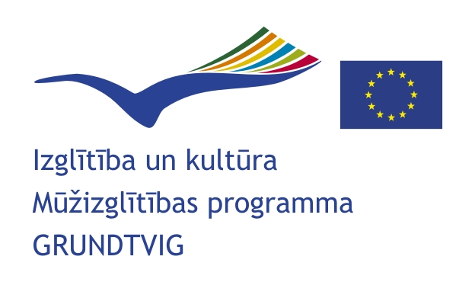
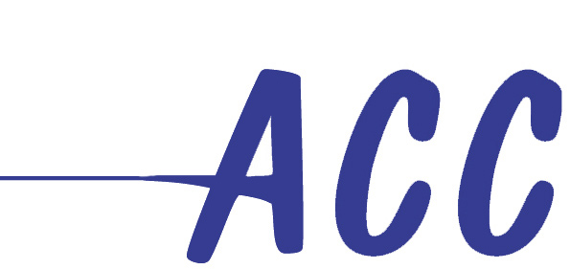

Information a Grundtvig workshop
“Europeans knowing Europe”
(2009-1-LV2-GRU13-00643)

A non-governmental organisation ACC Community Colleges for Latvia with the support of the EU Lifelong learning programme GRUNDTVIG is organising a workshop “Europeans knowing Europe” from June 19 – June 26, 2010 in Sārnate, Latvia.

The target group of the Workshop: Europeans that have been involved in some kind of European activities. People that have had at least once in their life time some European experience through their job or life situations (e.g. training, practicum, Erasmus period, job, living abroad). The selection of 20 participants will be done on the basis of their interest on the topic 'European citizenship and media'.

The working language of the workshop is English.

The selection of participants will be done on the basis of their interest on the topic 'European
citizenship and media'. The aim of the organisers is to select a diverse group of participants taking
into account their personal European experiences, professional background, gender, age and
regional balance among other criteria.

The expenses of travelling and stay in Latvia will be covered if the participants chose to travel by the cheapest possible means. The participants have to be citizens from the EU Member States, Iceland, Norway, Liechtenstein or Turkey. The participants from Latvia are welcome to apply but they will have to cover their own expenses.

The trainers of the workshop: Conchi Gallego (Spain), John Petersen (Denmark) and Linda Jākobsone (Latvia) have extensive experience and training in the work with media related to the issues of European Union covering various aspects.

The deadline for application: March 15, the answer to the participants will be sent my March 29.

Preliminary Programme of the event:

June 19 | Arrival of participants
June 20 | Welcome to participants  Analysing expectations  Presentation of the programme  Ice-breakers and team building activities  Lecture&Debate: European Public sphere - is it there?  Working with the work done at home  Welcome dinner
June 21 | Group dynamics: European citizenship  Brainstorm on different ways of promoting active citizenship  Group presentation: Europe in the national media
June 22 | Lecture&Debate: Is there room for European media?  A European Publication: presenting the task
June 23 | Open Space Technology: Topics of interest at European level  Setting up the editorial office  Social activity
June 24 | Working on the production of a European magazine
June 25 | Presenting the results  Evaluation  Farewell party
June 26 | Departure

Contact information:
Linda Jākobsone
acc.latvija@gmail.com
+ 371 29123348

